Student’s name | …………………………………………………….…… | Grade | 5
Subject | Computer | Week No. | 2
Lesson Title | Computers Around Us | Unit
Worksheet No. ( 2 ) (Answer)

Instruction: Match the following

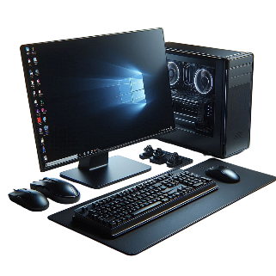 | smartwatch
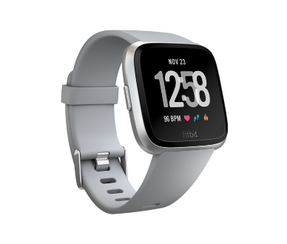 | PC or Computer
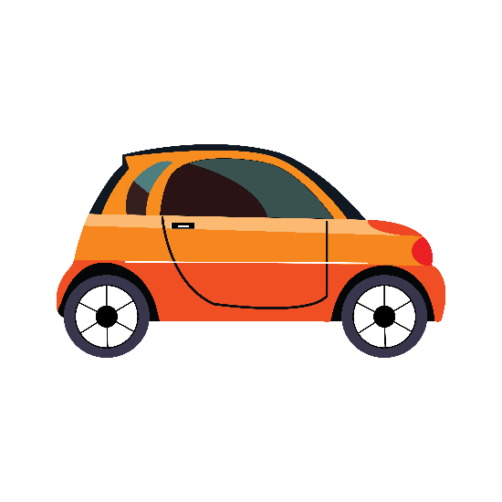 | Smart Glasses
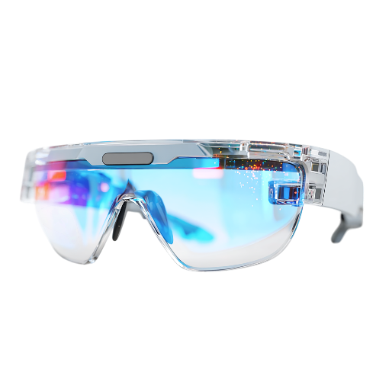 | Smart Car

Good Luck

